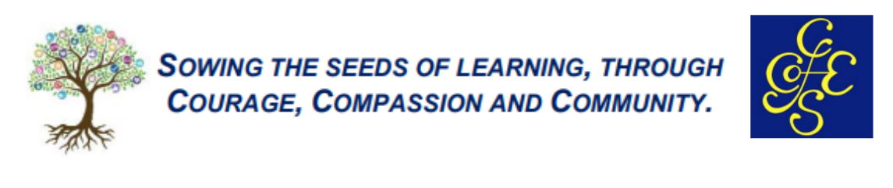
DESIGN TECHNOLOGY
INTENT
The Design Technology curriculum taught in Cranham C of E Primary, is designed to enable pupils to explore their creativity, imagination and to make products to solve real life problems. Teachers plan practical lessons with care to ensure the children are taught a progression of skills throughout their journey through the year groups. It is our intent to deliver units of work that are inspiring and purposeful to their wider learning. Children will make links with wider curriculum areas such as Mathematics, Science, Computing, Art, and the Humanities, where they can apply their skills to practical tasks and projects. It is hoped that with time taken to explore and evaluate past and present designs, the children will be able to understand the impact of everyday objects on their lives and that in the Worldwide community. Care is taken to ensure that all learners are given the opportunity to engage in practical tasks and are supported to reach successful outcomes where necessary. The foundation blocks for learning are set in the early years, where the children regularly explore a range of resources including constructions toys, craft materials, simple tools and joining techniques. Here the children evaluate their creations verbally when looking to make improvements.

IMPLEMENTATION
Our curriculum is delivered through carefully planned units of work and focus on four main ideas of development. Children explore the four main themes as the progress through their primary education that include: Structures, Mechanisms, Textiles and Cooking and Nutrition. The units are delivered using a spiral curriculum. This means that each of the themes is revisited in each key phase, and pupils revisit each theme through a new unit that consolidates and builds on prior learning.
The Design Technology curriculum is delivered by a range of teachers and includes visiting specialists where appropriate. Staff receive CPD from working alongside specialist teachers, craftworkers etc. Each unit of work has been planned with purposeful links to the class topics and takes account of the pupils interests. As each theme is explored, children take time to study and evaluate previous designs and applications in real life contexts. They experiment new ideas to gain understanding. Class discussion and reasoning takes place when evaluating work, with children encouraged to comment on strengths and weaknesses in their work and that of others. Staff take time to introduce and model the correct vocabulary for the units of work being completed. We take care to make links with previous learning. Teachers assess the pupils understanding, application of skills and final pieces of work, along with their ability to evaluate. We provide feedback to children as their progress throughout each unit of work and support individuals as required, ensuring that all learners experience the process of, exploring, designing, making and evaluating.
We strive to provide the children with opportunities to celebrate their designs and enable them to exhibit and display their final pieces where possible. The school is committed to adapt an environmentally friendly approach, and resources projects with care, making use of recycled materials when available.
The EYFS framework is structured very differently to the national curriculum, yet pupils are given daily opportunities to develop their creativity and their use of simple tools. They too explore across the year the four main concepts, through a more play-based experience and linked to topics chosen throughout the year.
IMPACT
It is hoped that as the pupils progress through the Design Technology curriculum, they will build a sound foundation of understanding. As a result, they will be able to apply the skills acquired to future projects and have an appreciation of how designs are created and realised, and built upon. Our aim is for all pupils to experience successful outcomes in their units of work and will feel enabled to extend their knowledge as they enter the next stage of education.

