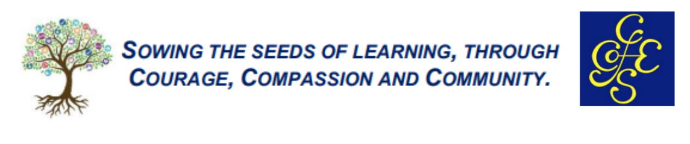
ART
INTENT, IMPLEMENTATION & IMPACT STATEMENT
INTENT
At Cranham C of E School it is our intent to plan and deliver a wide breadth of art and design experiences through out their time at our school. Teachers are ambitious in their approach, ensuring that all learners, including those who are disadvantaged, receive the same offer of experiences. Our curriculum is designed to build a sound knowledge of a range of art skills that is carefully sequenced and progressive across the key stages. They will study a carefully selected range of artists, craft workers, designers and architects, both contemporary and of historical note, building a sound knowledge and understanding of differing cultures and styles of art.
Our teaching builds upon the foundations laid in the EYFS, where children have been encouraged to develop both physical application of art materials and tools, to expressing themselves creatively. Each unit of work is planned to make meaningful links to the terms over-arching theme, whilst ensuring that the subject in its own right is taught effectively, building upon previous phases. Pupils work practically in sessions and take time to evaluate and study the work of others, making decisions on how the work of others may impact their own creative processes.
Effort is made to ensure access to all learners, including those with SEND can access the full art and design curriculum.

IMPLEMENTATION
Teachers have a sound knowledge of the art processes they teach and where appropriate the subject specialist leads units of work across the phases. Support is given to staff through CPD. Units of work are presented to children using a mix of firsthand experiences, experimenting with new materials and techniques, and by exploring the work of others. Pupils use vocabulary for experts when talking about art and design and are encouraged to discuss and evaluate the creative process throughout their study. Pupils receive demonstrations led by the teachers, and or by visitors, where strategies and techniques are studied in detail. Pupils are given feedback during the art and design sessions, and where appropriate, small plenaries are held to demonstrate successful application of skills, or to assist with areas of difficulty. Staff work alongside the children demonstrating their own artistic ability throughout the process. A calm, safe environment is created, where children feel free to explore their ideas confidently.
Where appropriate, links are made between previous units of work and experiences of style of art covered. For example: When completing a unit of work on pottery, the children will recall the methods used in the previous phase. Children will collate their work in sketchbooks, where the progression through the unit of work will be recorded. Information on Artists, Designers and Craftworkers will also be recorded in these books for future reference.
During their time at the school, pupils will have the opportunity to develop and revisit skills in drawing, painting, design, sculpture, pottery or ceramics, textiles and printing. They will use a progression of skills in each area, as can be seen in our progression map. Throughout the year children will be able to work individually and collaboratively to form pieces of art for pleasure and for public display.

IMPACT
As a result of following our planned art and design curriculum throughout the school, it is hoped that the pupils will be confident to apply a wide range of skills and techniques to new units of study, or when completing pieces of art for enjoyment. We hope that they will be equipped with the skills to evaluate the work of themselves and of others, and to talk confidently about their creativity and sources of inspiration. We believe that they will be well prepared for their next stage of Education and be able to carry forth the skills and understanding needed to succeed.

